Parking Information
Friday, December 11, Cats Only Vaccine Clinic Parking Details
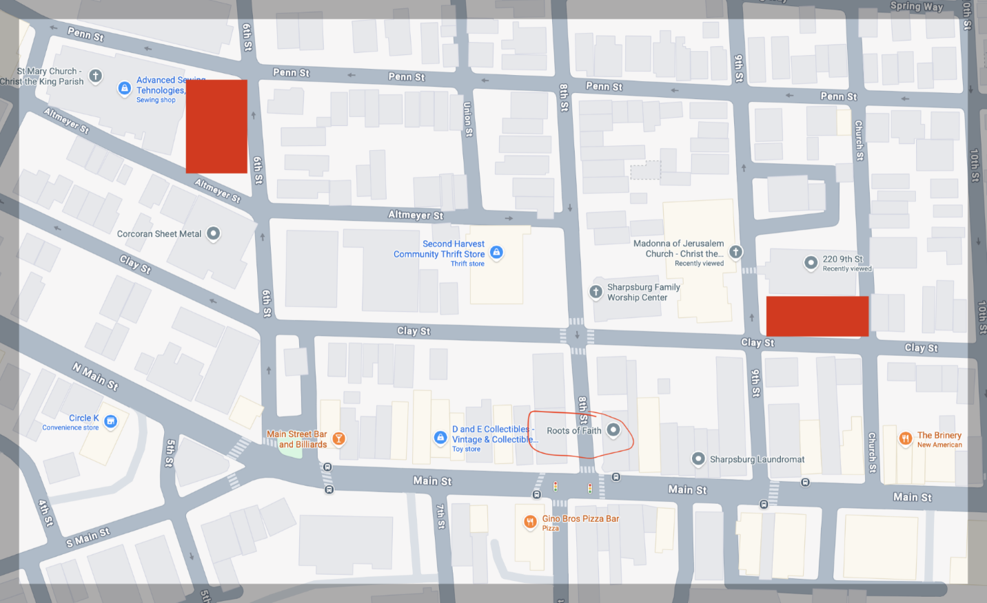
Addiction Recovery Ministry
201 9th Street
Pittsburgh, PA 15215

210 Garnier St
Pittsburgh, PA 15215
(This is for St. Mary’s Church – parking is available in the lot next to it)

